**TASK 1:**

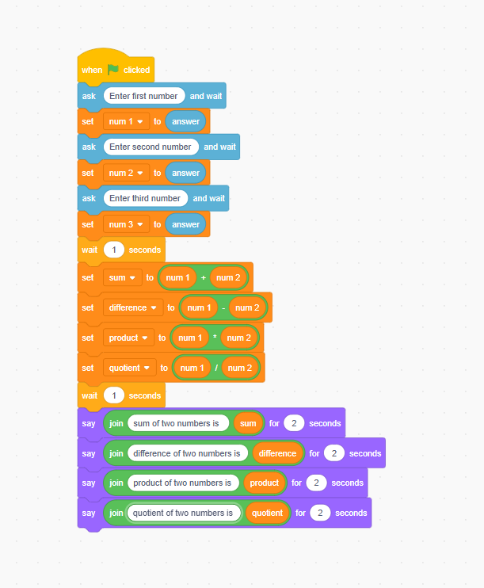**TASK 2:**

**TASK 3**:

**TASK 4:**

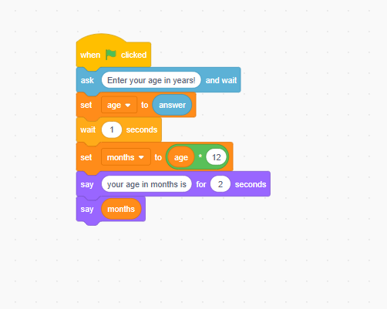

**TASK 5:**

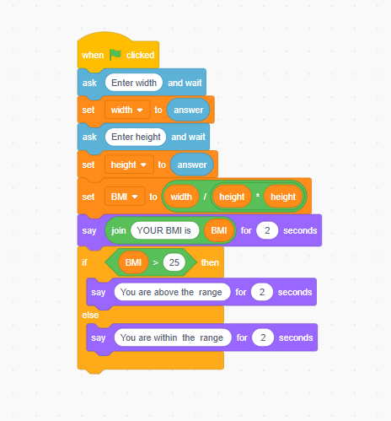

**TASK 6:**

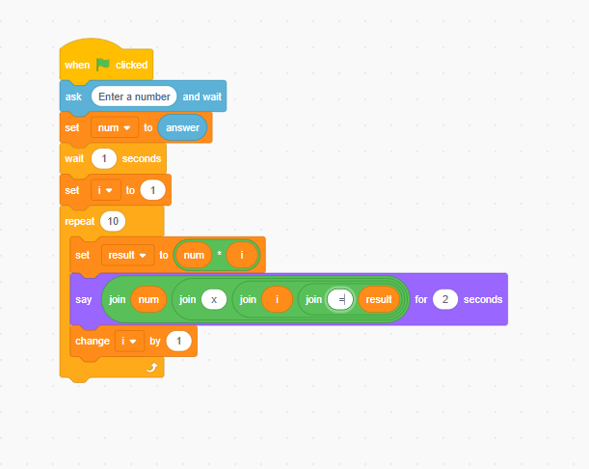

**TASK 7:**

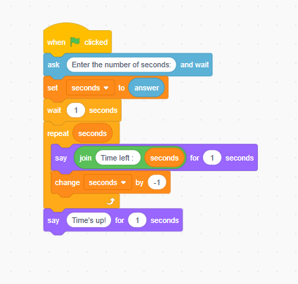

**TASK 8:**

**TASK 9:**

**TASK 10:**

